Name: _________________________________
Correlation Experiment or Study

Before you begin the written report,
- Decide whether to do an experiment (more points possible and extra credit available) or a study using data already gathered. If you do an experiment, you may work with one other student.
- Pick two explanatory variables and a response variable. Pick variables that you think might be correlated.
- Experiment: Pick variables for which individuals are associated with three numbers. For example, height, leg length, and 100 yard dash time. Do not pick variables with only a few values (e.g. true/false). You need numbers.
Study: In a sport of your choice, select a season that you are interested in. Use variables such as the number of rushing yards and the number of wins per team in a football season. You could choose to compare athletes instead of teams. You can use http://sports-reference.com.
- For this project, you don’t have to use a sport.
- You are encouraged to have at least 20 data points and no fewer than 10.
- For a more thorough investigation, study more explanatory variables, and compare the results. Another extension would be to do a hypothesis test for two of your explanatory variables.
To complete the written report,
- Write an introduction that gives a brief summary of the season or experiment you have chosen, a list of the teams/athletes/individuals you will be investigating, and why you chose to focus on the chosen variables.
- Predict, before doing your investigation, which of the two explanatory variables you think is a better predictor of the response. Make a prediction of whether the stronger correlation is significant.
- Record the pairs of PERFORMANCES for each team/athlete in a table.
Team Name | Response Variable  (y) | Explanatory Variable 1  (x₁) | Explanatory Variable 2  (x₂)
A
B
…
- Graph two scatter plots, one for each explanatory variable. Then describe and compare the two scatter plots, including a comparison of the correlation (r) using each explanatory variable.
- Do a hypothesis test for the variable with the stronger relationship to the response variable to see if the association is significant. Before you do the test, write down the hypotheses (H₀ and H_{a}). Simulate the distribution of the correlation assuming that the true correlation is 0. Use the results to estimate the p-value, interpret the p-value, and make an appropriate conclusion.
- Discuss what we know about what causes a correlation.

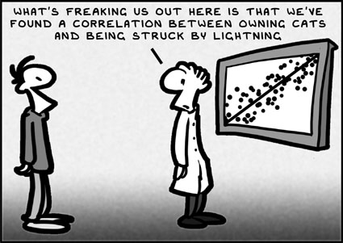

Grading Correlation Investigation | A complete report | Points
Introduction and Data Collection | - Describes the context for the research, including why a particular situation (sport/season/experiment) and variables were chosen  - Uses one response variable and two explanatory variables.  - Has a clearly stated question of interest  - States your prediction of which explanatory variable has the stronger correlation.  - States your prediction of whether the stronger correlation is significant (as determined using the hypothesis test).  - Describes how the data were collected  - Includes a table of all the data | (4)
Scatter Plots and Correlation | - Includes appropriate types of scatter plots  - Graphs are clearly labeled and easy to compare  - Correlation (r) is calculated  - Graphs are discussed/compared correctly | (4)
Hypothesis Test and Analysis | - The test statistic for the hypothesis test is defined  - Hypotheses are clearly stated  - Clearly describes method for performing a simulation and includes an large number of trials  - Displays results of simulation in a clear, well labeled dot plot  - Estimates the p-value correctly | (4)
Conclusions | - Correctly interprets p-value in context  - Correctly uses the results of the simulation to draw an appropriate conclusion about the question of interest  - Shows evidence of critical reflection (discusses possible errors, shortcomings, limitations, alternate explanations, etc.)  - Explains what can be learned about cause and effect from a correlation | (4)
Overall Presentation/ Communication | - Investigation is well organized, neat and easy to read  - Ideas are well communicated, including appropriate transitions between sections  - Investigation is focused on answering the question of interest | (2)
Experiment | - Has an experiment. (Points not available for a study.) | (2)
 | - Extra Credit for an experiment:  Originality, creativity, complexity of the experiment, and teamwork. | EC
Timeliness | Late penalty: –1 point/per day past the announced due date. | (–1/day)
Total | Max points available for a study: 18/20.  Max points available for an experiment: (20 + Extra Credit)/20. | (20) + EC

