Name: ______________________________
Decathlon z-Score Project Report Contents v. 1.1

The class organizes a multi-event competition and compares PERFORMANCES.

Title and Introduction (4 points)
- Title and student name
- Introduction explains the question of interest, i.e. who were the best athletes overall.
- Explains competition and how each event was run

Data Collection, Graphs, and Calculations (4 points)
- Table with each PERFORMANCE
- Dot plot of PERFORMANCES for each event
- Calculates mean and standard deviation for each event

Analysis (4 points)
- Calculates all z-scores in a table
- Show how one z-score was calculated (an example such as Joe in the long jump) and interpret it (explain in words what it means)
- For each event, make a dot plot with z-scores on the horizontal axis. Preferably, put the z-scores for each event into one plot (for example, by using categorical data in Fathom).
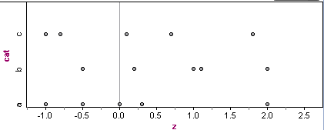
- Looking at the z-scores for all events, how many percent of the PERFORMANCES fall within ±1 standard deviation of the mean? How does this make sense?

Conclusion (4 points)
- Construct the overall z-score, one per participant, and explain how you did it.
- Answer the question of interest and justify it.
- Show evidence of critical reflection (discusses possible errors and limitations, and how the competition can be improved, etc.)
- What are some alternate ways of answering the question of interest? Which is better?

Overall Presentation/Communication (4 points)
- Clear, holistic picture of the investigation, including a discussion about the usefulness of z-scores for making comparisons across events
- Investigation is well organized, neat and easy to read
- Ideas are well communicated, including appropriate transitions between sections

